**6. SL4J Logging exercises**

**Exercise 1: Logging Error Messages and Warning Levels Task**

To write a Java application that demonstrates logging error messages and warning levels using SLF4J.

**Step 1**

Added SLF4J and Logback dependencies to your `pom.xml` file:

**Step 2**

Created a Java class that uses SLF4J for logging

import org.slf4j.Logger;

import org.slf4j.LoggerFactory;

public class LoggingExample

{ private static final Logger logger = LoggerFactory.getLogger(LoggingExample.class);

public static void main(String[] args)

{ logger.error("This is an error message");

logger.warn("This is a warning message"); } }

**Output**

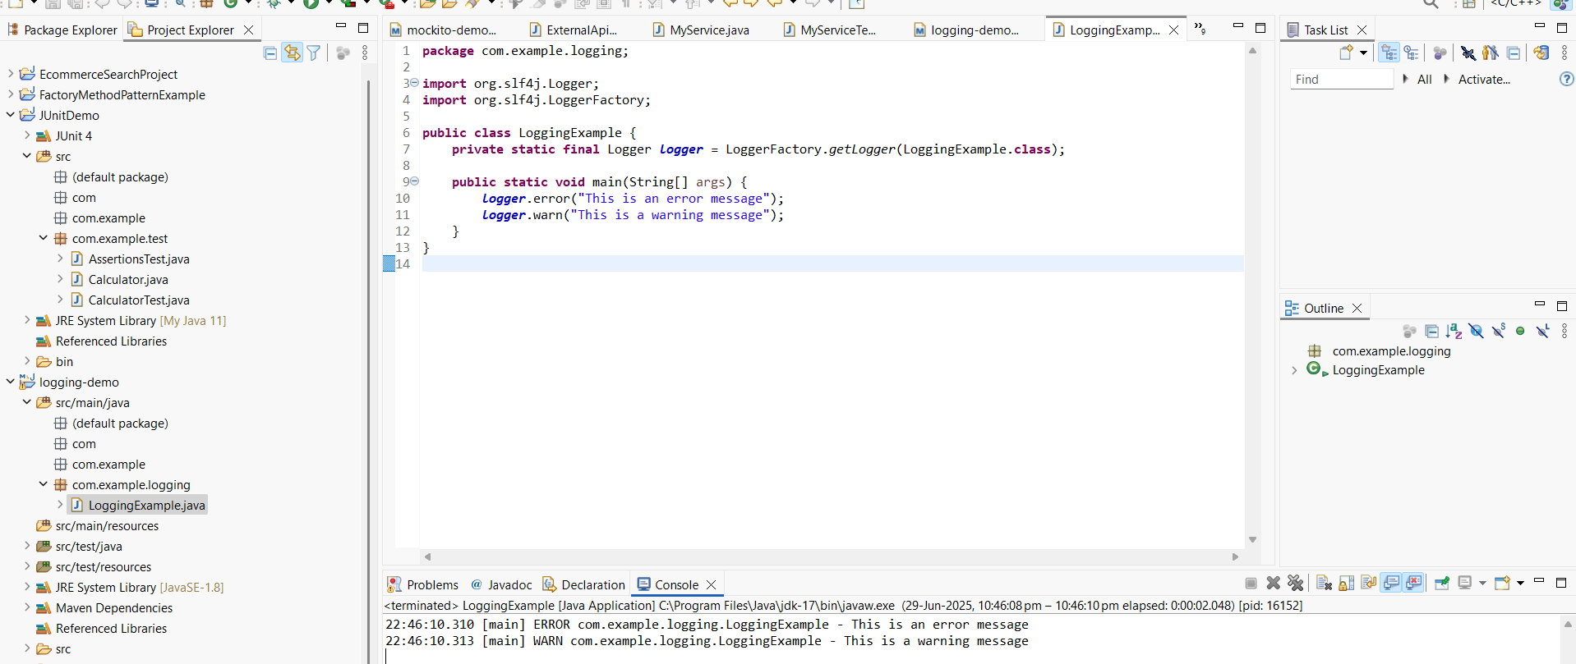

22:46:10.310 [main] ERROR com.example.logging.LoggingExample - This is an error message

22:46:10.313 [main] WARN com.example.logging.LoggingExample - This is a warning message